26. FRUIT AND ITS COLOR USING BACKTRACKING
Aim
To write a Prolog program to identify the color of a fruit using facts, rules, and backtracking.
Objective
- To understand the basic concepts of Prolog.
- To represent fruits and their colors using facts.
- To use rules for querying fruit colors.
- To understand how Prolog uses backtracking to find multiple solutions.
Algorithm
- Start the program.
- Define facts representing fruits and their colors.
- Define a rule fruit_color/2 to find the color of a given fruit.
- Enter a query with a fruit name.
- Prolog searches the facts from top to bottom.
- If a matching fact is found, Prolog returns the corresponding color.
- If the user requests another solution using ;, Prolog performs backtracking and searches for another matching fact.
- Display the result.
- Stop.
Flowchart
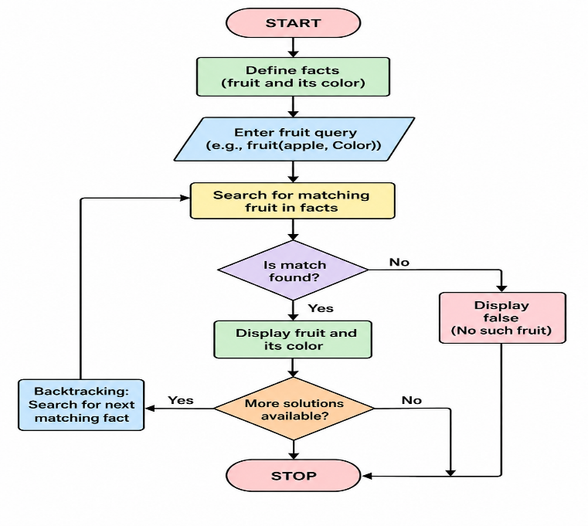
Prolog Code
% Facts: fruit and its color
fruit_color(apple, red).
fruit_color(apple, green).
fruit_color(banana, yellow).
fruit_color(orange, orange).
fruit_color(grape, purple).
fruit_color(grape, green).
fruit_color(mango, yellow).
fruit_color(mango, green).
Output:
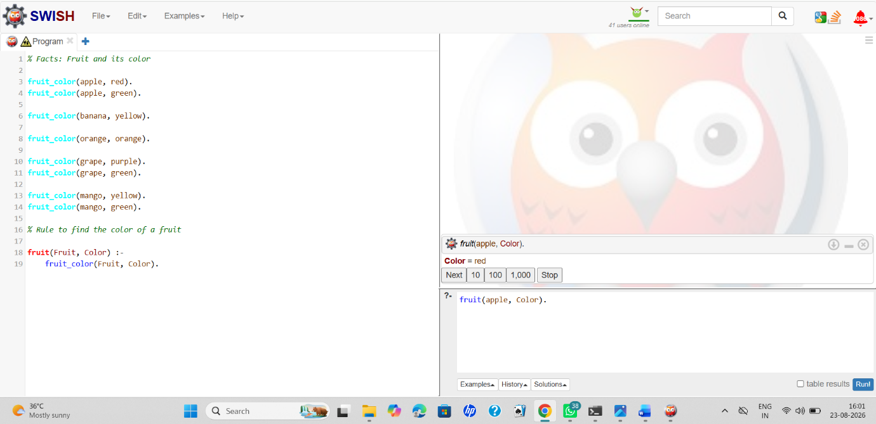
Result
Thus, the Prolog program to identify the color of a fruit using backtracking was successfully implemented and executed. Prolog returns the possible colors one by one, demonstrating the concept of backtracking.

